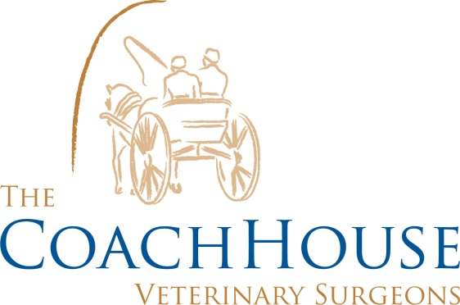

ANAESTHESIA
At Coach House Vets, we strive for the best care for your pets. Your animal’s procedure will be carried out by a Veterinary Surgeon whilst your animal is monitored by a Veterinary Nurse. All of our staff members are trained in each of their roles.
Your animal will be admitted in morning consults and spend the day with us. Once admitted a general health check is carried out, this includes their current weight, temperature, heart rate and respiration rate.
A calculated dose of pre-medication is given to your pet, this will make them feel sleepy but also provides your animal with pain relief before the procedure is carried out.
We then carry out all the necessary checks on all the anaesthetic equipment before each procedure. Your animal is assigned a monitoring sheet, so we can record all their readings throughout their procedure and is provided with an endo-tracheal tube. This endo-tracheal tube is placed down the airways to allow oxygen and inhalation gases to your animal.
Your animal is then induced with an induction agent at the beginning of their anaesthetic. This ensures that they have a gradual stress free transition into a safe anaesthesia. This induction agent lasts approximately 20 minutes; the anaesthesia is then maintained via inhalation gases and oxygen for a balanced anaesthetic throughout their procedure.
During any procedure, your animal is constantly monitored by one of our nurses. The nurses take their heart rate via stethoscope and feeling their pulses, temperature and respiration rate as a baseline. Their reflexes are also checked on their eyes, toes and jaw to ensure their anaesthetic plane is correct. Their gum colour and the capillary refill time is taken (by pressing their gums and watching the colour change) to ensure their anaesthetic depth is precise. Your animal’s blood pressure is also taken throughout to ensure that is not going too high or low. We also take your animals saturated oxygen percentage, showing how much oxygen is ‘sat’ within your animal’s tissues to ensure their oxygen flow is accurate.
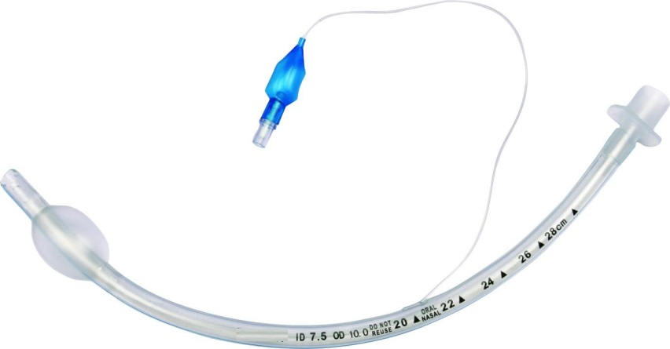
When your animal recovers, one of our nurses gives them over 5 minutes of pure oxygen and sits with them whilst they recover. Your animal is routinely checked to ensure a smooth recovery. It is at this point we will give you a ring to arrange a discharge time. In the afternoon, normally about an hour or so after your animal’s procedure, we will take them out for a wee and provide them with bland food and water.

