CAT VACCINATIONS
At Coach House Vets we use Nobivac Vaccinations. We will explain below what each disease is and why you are protecting your animal from such diseases.
Kitten Course =
1st Vaccination = from 8 weeks of age. This includes Rhinotracheitis, Calicivirus, Panleucopenia and Feline Leukaemia Virus.
2nd Vaccination = this is given 3-4 weeks after their first vaccination. This vaccination includes the same as the above.
A kitten is protected 2 weeks after their second vaccination, but it is advised not to let them outdoors until they have been neutered and microchipped at 5-6 months.

Booster =
This should be given annually in the same month that your 2nd vaccination was given to your dog. Boosters are important to keep your animals immunity at the level it should be to prevent the onset of any diseases. Each booster contains different ‘parts’ of the vaccination as not all the diseases are needed to be ‘topped-up’ each year. This regime avoids us over-vaccinating cats for feline panleukopenia virus.
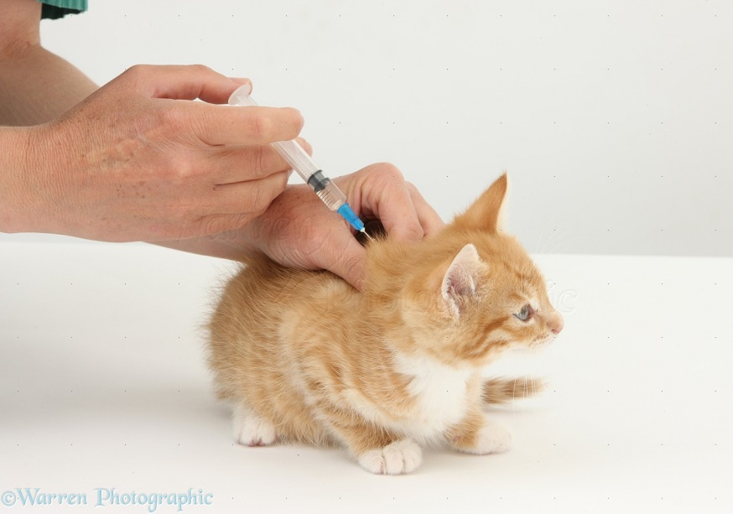

Rhinotracheitis = This is an upper respiratory infection of the nose and throat in cats. It can cause sudden bouts of sneezing and watery/pussy discharge from the nose. It is transmitted via direct contact with another infected cat by their excretions from nose and eyes. It has an incubation period of 2-5 days and can be treated with antibiotics after diagnosed. We may suggest running some bloods to check to see if your cat is fighting an infection to aid the diagnosis.
Calicivirus = Is a virus that mainly causes acute upper respiratory infections in cats that is readily transmitted between cats through: direct contact of secretions, inhalation of droplets or sharing food bowls and litter trays. It can survive for a month in the environment but has an incubation period of 2-6 days. Symptoms include; discharge from eyes and nose, gingivitis of the gums, loss of appetite and lethargy. To diagnose this swabs are taken of the discharge from your animal and sent to an external lab.
Panleukopenia = Is a highly contagious and life-threatening viral disease in the cat population. This virus affects the rapidly dividing blood cells in the body, primarily the cells in the intestinal tract and bone marrow. As the blood cells are under attack, this virus can lead to an anaemic condition, and it can open the body to infections from other illnesses – viral or bacterial. Symptoms of this include; neurological symptoms, high fever, weight loss and vomiting. The incubation period is less than 14 days and is spread by contact with infected blood, faeces, urine or fleas. It can also be passed via sharing bedding, food bowls and litter trays. Treatment includes admission for intravenous fluids, asymptomatic medication (i.e. anti-sickness to help with vomiting) and possible blood transfusion.
Feline Leukaemia Virus = This is also known as FeLV. It is a disease that impairs the cat's immune system and causes certain types of cancer. The incubation period is 8 weeks and symptoms include; weight loss, fever, diarrhoea and inflammation of tissues (i.e. gums and eyes). This can be contracted via direct contact from sharing bowls and litter trays or passed down in the mother’s milk. For diagnosing this bloods are usually taken and treatment can include; nutritional support, fluids and specialised diets.

