COMMON POISONINGS FOR DOGS
Chocolate
The darker and more bitter the chocolate, the more dangerous it is to dog. Chocolate is toxic because it contains a chemical called theobromine, as well as caffeine. Dogs cannot metabolise these chemicals meaning their organs can be affected. For many dogs, the most common clinical signs are vomiting and diarrhoea, increased thirst, panting or restlessness, excessive urination, and a racing heart rate. If your dog has eaten chocolate, ring us immediately as we can make your dog sick if the chocolate was eaten recently. If not, it may mean we need to take some bloods to ensure all their organs are coping and we may keep them in overnight on fluids to help flush out the toxins.
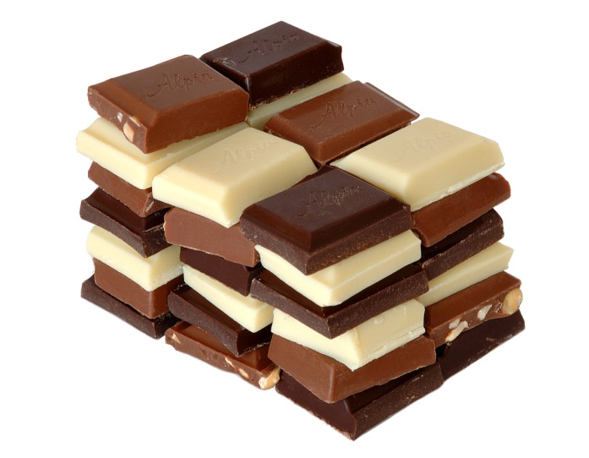
Grapes, Sultanas and Raisins
Although the exact substance that causes the toxic reaction is not yet known, dogs should not eat grapes and raisins because even small amounts can prove to be fatally toxic for a dog. It causes acute kidney failure with a lack of urine production. It can cause your dog to vomit, lose their appetite and to become lethargic. Please contact us immediately if your dog eats grapes as we can make your dog vomit and/or hospitalise them to put them on fluids to flush the toxins out of the system. We may also suggest taking some bloods from your dog to check their kidneys.
Slug Pellets
Metaldehyde is in many slug pellets. This chemical is readily absorbed into the gastrointestinal tract. This can cause neurological issues with your pet including; muscle tremors, loss of balance and high respiration rate. It can also cause your animal to have convulsions. There is no specific treatment for this poisoning but can treat for each symptom and administer activated charcoal to line the stomach and help excrete the metaldehyde.
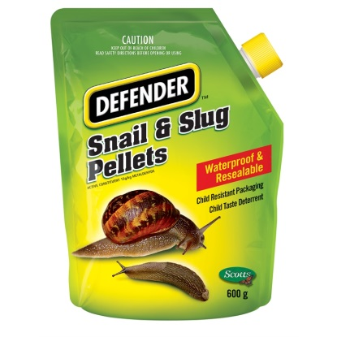
Xylitol
Is a sugar found in many gums, sweets and peanut butter. Xylitol is extremely toxic to dogs. Even small amounts of xylitol can cause hypoglycaemia (low blood sugar), seizures, liver failure or even death in dog. This is because xylitol is quickly absorbed into the bloodstream, resulting in a potent release of insulin from the pancreas causing their blood glucose to drop. Animals become lethargic and weak after eating xylitol. Your animal would need to admitted to provide sugar supplementation, intravenous fluids, and liver protective drugs.

Ibruprofen
Common signs include; pale gums, abdominal pain and lethargy. If eaten it can cause kidney failure in your animal so it is imperative if you suspect your animal has eaten this to ring us. We would recommend that your animal comes in for admission to be placed on intravenous fluids and supportive medication.
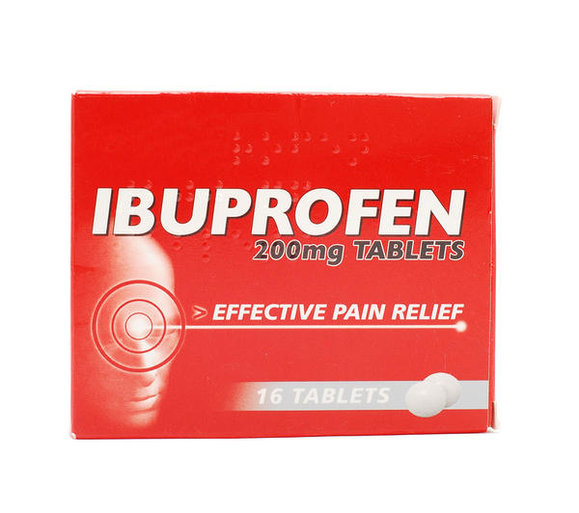

If you have any concerns please ring us on 01635 254544.

