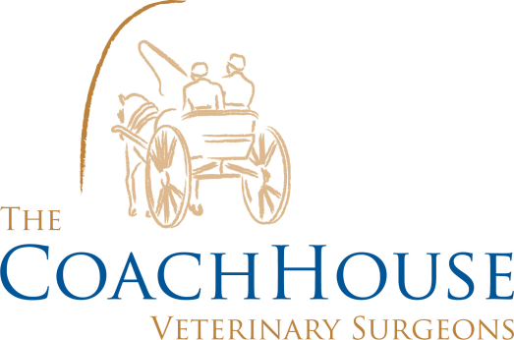

COMMON POISONS IN CATS
Antifreeze
Antifreeze contains ethlyene glycol. It causes toxicity that is potentially fatal to cats. Cats usually come into contact with antifreeze when it leaks from a car's engine onto the ground. Cats are drawn to it as antifreeze has a “sweet taste”. If your cat ingests this you may see symptoms of; loss of balance, twitching muscles and increased thirst and urination. It can cause the kidneys to stop working so for treatment intravenous fluids are often required to prevent dehydration. Bicarbonate is also given intravenously to correct the pH within the body as it often drops too low.
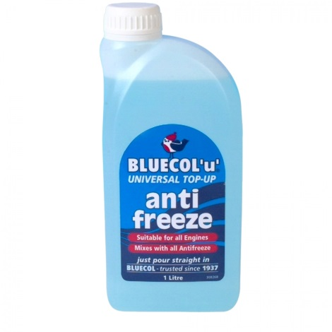
Lilly’s
It depends on which type of Lillie is eaten but most cause your animal to vomit, drool and foam at the mouth. Again, different Lilly’s can cause different affects within the animal. Some Lilly’s can cause the animals heart to become irregular and slow down or other lilly’s can cause the animals kidneys to stop working effectively. It is imperative that you bring your cat to us immediately to place onto intravenous fluids and treat for each symptom. We may also recommend bloods to check your cat’s kidneys.
Spot on Dog Treatment
Some dog treatments contain the ingredient, Permethrin. The higher dosage in dog treatment can mean that’s cats are heavily overdosed if used. It affects the central nervous system by causing the cat to have seizures, as permethrin can pass into the brain. The cat should be bathed straight away to wash away as much of the spot on as possible and often are given activated charcoal to help the body.
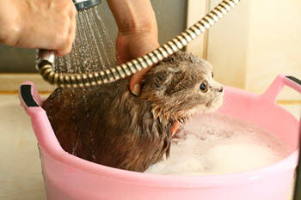
Slug Pellets
Metaldehyde is in many slug pellets. This chemical is readily absorbed into the gastrointestinal tract. This can cause neurological issues with your pet including; muscle tremors, loss of balance and high respiration rate. It can also cause your animal to have convulsions. There is no specific treatment for this poisoning but can treat for each symptom and administer activated charcoal to line the stomach and help excrete the metaldehyde.

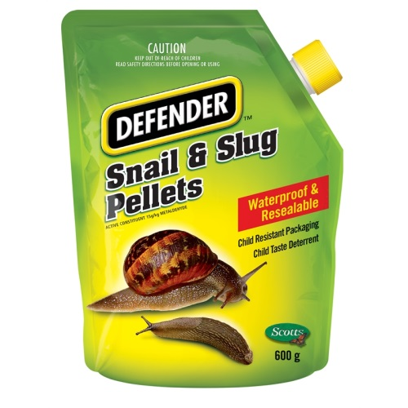
If you have any concerns please ring us on 01635 254544.

