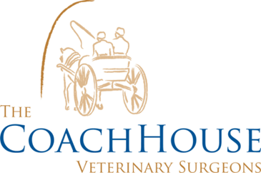

RABBIT VACCINATIONS
Course =
1st Vaccination = this can be done at 5 weeks of age. This vaccination includes; myxomatosis and viral haemorrhagic disease.
Booster =
This is done annually on the same month the first vaccination was given. The vaccine contains the same as the above.
Myxomatosis = is a viral disease which causes an infected rabbit to become depressed, have a temperature and stop eating. It is characterised by swellings and sticky discharges around the eyes, nose and genital areas; other swellings are found on the skin. Secondary respiratory infections are common. Treatment is rarely successful and affected rabbits suffer a great deal which is why it is important to vaccinate against. Myxomatosis is spread by biting insects, usually fleas or mosquitoes. As mosquitoes can fly and be carried long distances on the wind, even if a rabbit has no contact with other pet rabbits or wild rabbits, it will still be at risk. Even house rabbits can be bitten by flying insects.

Viral Haemorrhagic Disease =
Viral haemorrhagic disease (VHD) is a viral disease of rabbits, which is rapidly fatal. Affected animals may be found depressed, collapsed and/or with haemorrhagic (bloody) diarrhoea. It is spread through direct contact with a diseased animal but unfortunately lasts a long time within the environment so can be picked up on shoes, bedding etc. and carried out to the garden where your rabbit is kept.
There is a similar strain referred to as the as RHVD2 strain which can be vaccinated against. However, it is not yet prevalent in the Berkshire area.

