PARASITE LIFECYCLES – SMALL ANIMAL
Flea Lifecycle:
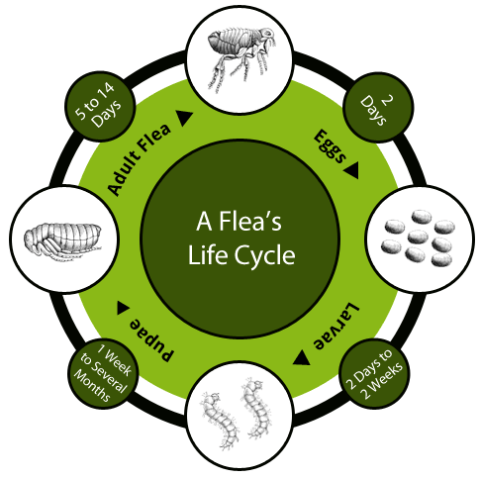
The larvae and pupae of the flea often are not seen on the animal as are usually within the household, such as your carpet! To help eliminate fleas ensure your pets flea treatment is up to date and we offer aerosol sprays to help eliminate fleas from your home.
Tick Lifecycle:
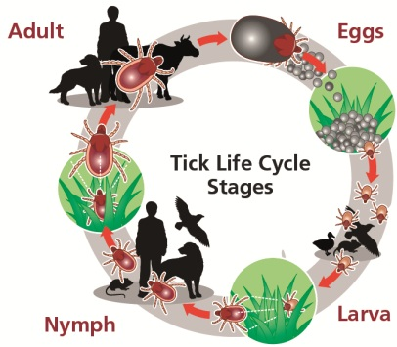
Ticks are often seen within the spring and summer months so to ensure your animal does not get ticks, ensure that their tick treatment is up to date. Ticks can carry diseases such as; Lymes disease which can affect humans. Ticks can be removed using a tick remover found in local stores at here at Coach House Vets. If you are squeamish about ticks, we will also remove them for you!
Whipworm Lifecycle:
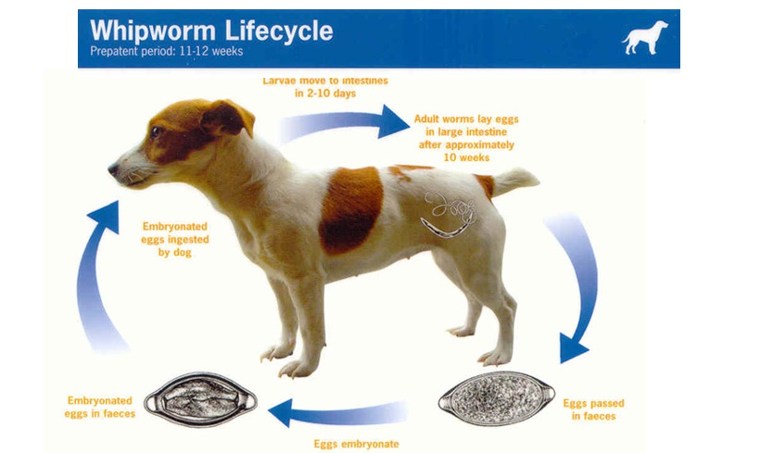
Whipworms can cause your animal to have an upset stomach as they stay within your animal’s digestive system. To avoid these worms, ensure your animal is up to date with their wormer.

Hookworm Lifecycle:
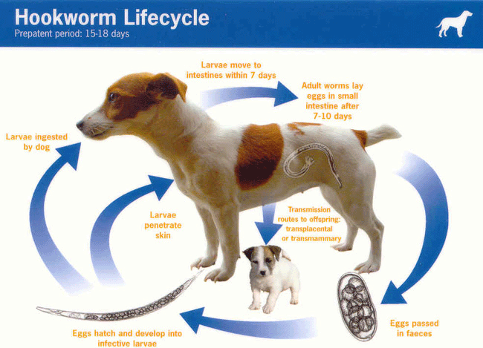
Hookworm can cause your animal to have an upset stomach as they stay within your animal’s digestive system. To avoid these worms, ensure your animal is up to date with their wormer.

Roundworm Lifecycle:
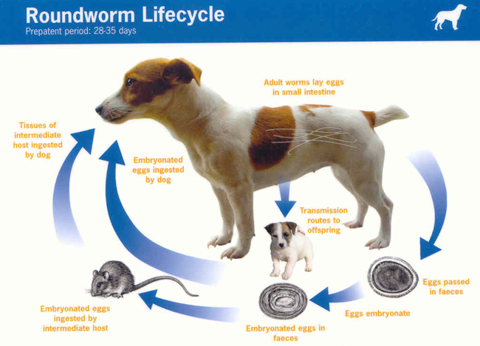
Roundworm can cause your animal to have an upset stomach as they stay within your animal’s digestive system. To avoid these worms, ensure your animal is up to date with their wormer.

Angiostrongylus (Lungworm) Lifecycle:
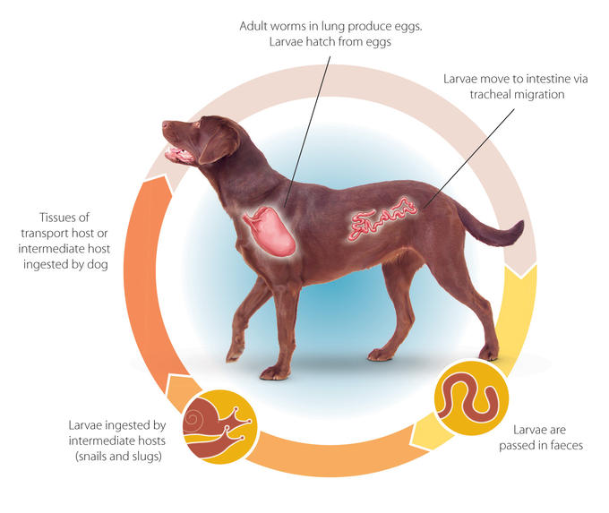
Lungworm can be fatal to your animal so please ensure that your animal is up to date with its wormer. Lungworm can affect your animal’s organs so is vital to keep up to date!

Heartworm Lifecycle:
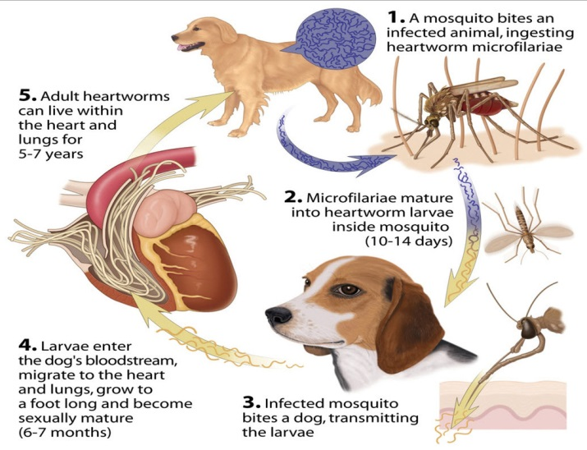
Heart worm can have impacts on your animal’s heart and lung meaning these organs struggle to do their job. This is why your animal should keep up to date with their worming.

Tapeworm Lifecycle:
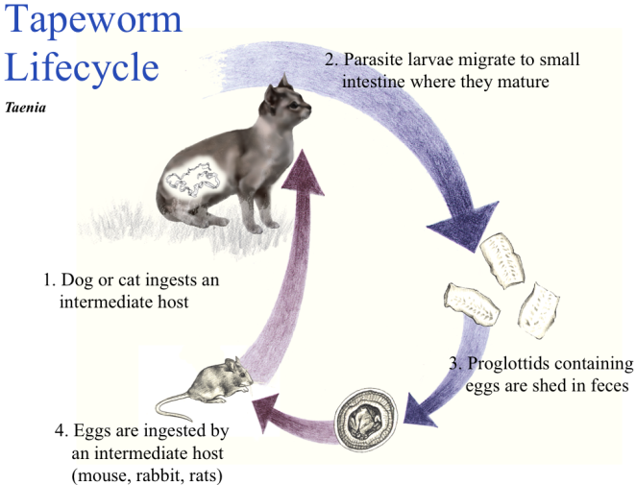
Tapeworm can cause your animal to have an upset stomach as they stay within your animal’s digestive system. To avoid these worms, ensure your animal is up to date with their wormer.

Otodectes Lifecycle:
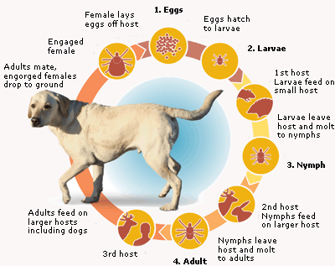
Otodectes is a common ear mite that may cause your animal to scratch their ear lots or head shake. A brown wax can appear that later can go crusty.
Sarcoptes Lifecycle:
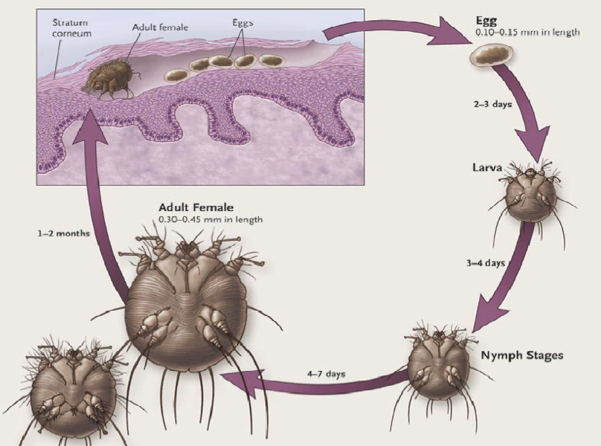
This is the mite responsible for scabies. This can cause your animals skin to become scaly, red and sore.

Demodex Lifecycle:
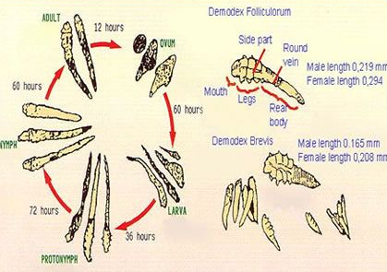
Demodex are mites that live around your animals hair follicles. An overpopulation of demodex can cause alopecia and thick red patches over your animal’s fur.

Louse Lifecycle:
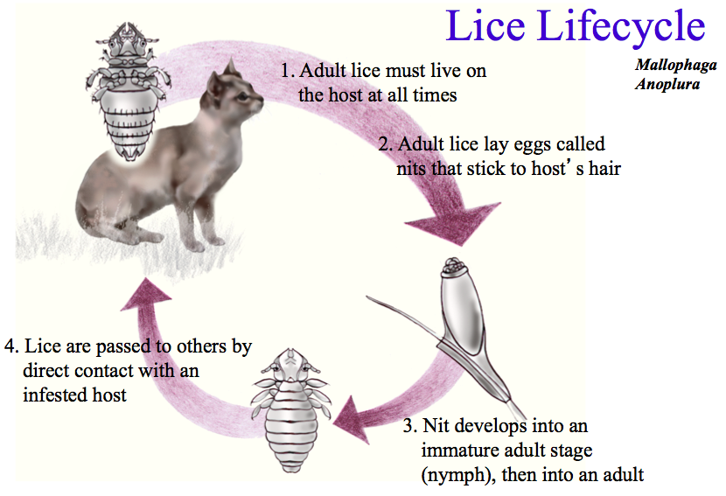
Louse can cause severe itchiness for your animal. If your animal continues to scratch, it can cause their skin to become inflamed and sore.

All of these parasites can be avoided with simple treatment regularly from us here at Coach House Vets. If you have any questions, please ring us on 01635 254544.

