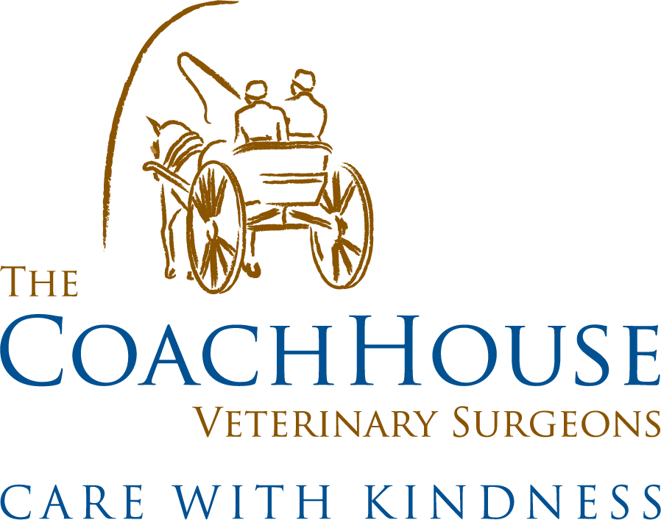

Welcome to our Team

Welcome
Thank you for choosing our team to help you care for your family pets. Our friendly vets, nurses and support staff will treat you as a trusted friend and your pets as if they are our own. We’ll provide the very best advice, treatment and care. We are a fiercely independent practice (no anonymous shareholders) and we’re proud of the service we provide you.
Care with…
We know that you want to keep your pets in tiptop health. Our vets and nurses can help with their experience, knowledge and a comprehensive suite of routine healthcare services.
…kindness…
We also know that, when things go wrong, you want a speedy resolution. Phill, Niamh, Gabby, and Beth have the expertise and equipment to help you return your furry friend to full health. In addition to seeing your pet we’re always on the end of the phone to support you through the difficult times.
24 hours a day, 365 days of the year
We pride ourselves in providing a 24-hour emergency service, ensuring you can be seen day or night, 365 days of the year, either by one of our own team members at one of our surgeries or our out of hours provider MiNightVet in Winchester.
For out of hours assistance please always phone our usual number 01635 254544.

Who’s who?
Dr Phill Robinson MRCVS – veterinary surgeon
01635254544 – phill@coachhousevets.com
Dr Niamh Borman MRCVS – veterinary surgeon
01635254544 – niamh@coachhousevets.com
Dr Chris Tufnell FRCVS – veterinary surgeon
07879474948 – chris@coachhousevets.com
Dr Mateus Forni MRCVS – veterinary surgeon
07919203966 - mateus@coachhousevets.com
Gabby Copping RVN – Head veterinary nurse
01635254544 – gabby@coachhousevets.com
Beth Frankum RVN – registered veterinary nurse
01635254544 – beth@coachhousevets.com
Emma Shojaie – admin manager
01635254544 – reception@coachhousevets.com
Becky Ind – reception team
01635254544 – reception@coachhousevets.com
Ali Brown – animal nursing assistant
01635254544 – reception@coachhousevets.com
Continuous Improvement & Lifelong Learning
Our practice is accredited under the Royal College of Veterinary Surgeons (RCVS – the UK veterinary regulator) Practice Standards Scheme, a voluntary quality assurance programme, and we have been awarded Outstanding for customer service having passed a rigorous inspection carried out by an experienced veterinary surgeon or nurse. RCVS accreditation means peace of mind for you, quality care for your animals and regular inspections of our practice.
We are a Silver Cat Friendly Clinic through the International Society of Feline Medicine and a Bronze Practice with Compassion Understood, which recognises the exceptional care that we offer when the sad day to say goodbye comes.
We are also a veterinary nurse training practice and a veterinary student training practice for the Royal Veterinary College (RVC – London Vet School. We know! It’s confusing!)

Finally, all our vets and nurses regularly undertake Continuing Professional Development (CPD) to ensure that we remain up to date.
Our Services
Our exceptional team provide an extensive range of services to enable us to help you keep your pets in good health, as well as getting them swiftly well again if they are sick or injured.
Routine healthcare
We take keeping your dog, cat or small pet healthy very seriously (although we’re happy to deliver it with a smile and a laugh!). We’re happy to perform check ups and in-house blood screens at any time, offer a range of vaccinations against nasty diseases and advice, control & treatment for parasites such as worms, fleas and ticks. Our fantastic nurses offer clinics for clipping nails, expressing anal glands (not a nice job!) and weight watchers.
We regularly provide routine neutering (spaying and castration), microchipping to help with the return of lost pets and export paperwork to permit overseas travel with your pet.
Coach House Care Scheme . ……………………………
The Coach House Care Scheme is to help make routine preventative healthcare easy, we’ll remind you when it’s required, and spread payments by a monthly direct debit. Coach House Care also gives further discounts on our other services, please see our Coach House Care leaflet for more detail. All parasite control is delivered straight to your door!
When things go wrong
During our opening hours you will have telephone access to one of our own vets and can make an appointment for a consultation in which we’ll give you as much time as is needed. If required we have warm comfortable hospitalisation facilities and our nurses and nursing assistants provide unlimited cuddles to make your pet feel at home. We’ll keep in touch with you if your pet has to stay with us as we know that you’ll be worried.
Outside of our opening hours we have our out of hours provider We have partnered with MiNightVet Winchester who offer first class dedicated out of hours services. Their caring team of vets and nurses are fully trained and have special interest in emergency and critical care. They are ready to provide your pet with the same excellent care you expect from us here at Coach House. This ensures that someone is always alert and ready to see your pet even during unsociable hours. This support allows our vets to be refreshed and ready to see your pets in the daytime.
MiNightVet in Winchester will take your calls from Monday – Thursday after 9pm, Friday after 7pm and Saturday from 4pm through until Monday at 8.00am. Otherwise, you will get through to one of our vets at Coach House who will of course, be more than happy to help and see your pet if needed!

Our vets perform many surgical procedures in our operating theatre with our nurses monitoring your pet’s anaesthesia, we have state of the art monitoring equipment to ensure each anaesthetic is as safe as possible. For in depth investigations we have digital x-ray, ultrasonography (scanning), endoscopy, and for helping us work out what’s wrong and our own, in-house laboratory for a fast turnaround of tests. We also have a dental machine to ensure we can offer all types of pets dental care. To speed up recovery we offer laser therapy, physiotherapy and our nurses carry out post surgical checks and bandage changes.
Our team will work tirelessly to speedily return your family member, be they dog, cat or small pet, to happiness and full health.
Operations
Operations take place Monday to Friday with most patients returning home the same day as their surgery (some patients may need to stay in for a night or so, for some extra tlc after long non-routine operations). We perform pre-anaesthetic blood tests on older and higher risk animals to minimise the risks of anaesthesia and surgery. We will also talk to you about if your pet would benefit from receiving fluid therapy whilst in with us. Pain relief is administered to all surgical patients and intensive monitoring is carried out by one of our trained nurses throughout their procedure and recovery to ensure that they go home safe and well. We will not discharge your pet until we are fully satisfied that they are safe to return home.
Specialist Support
We are fortunate to work closely with a number of Veterinary Hospitals across the area for those trickier and very serious cases where Specialist attention is required. Either we can consult them for advice or will refer your pet to be seen by one of their Specialists.……………………………
Prescriptions
Please give us 24 hours notice for drug prescriptions and food. In accordance with prescribing legislation all animals receiving prescription medications need to re-examined regularly by a veterinary surgeon. We’ll advise you when the examinations are due.
Fees
As there is no NHS for pets, all independent veterinary practices are funded by the fees that you pay. We aim to provide the best value for money and to do this, fees are payable at the time. To facilitate payment, we are happy to accept most credit and debit cards or cash. We can also take payment via BACS or over the telephone. We hugely appreciate your assistance with this. Thank you.
We look forward to getting to know you and your pets and look forward to helping you care for them for many years. Please don’t hesitate to contact us at any time.
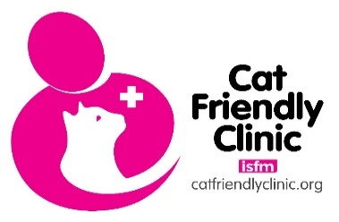
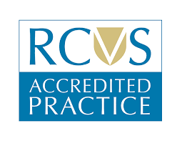
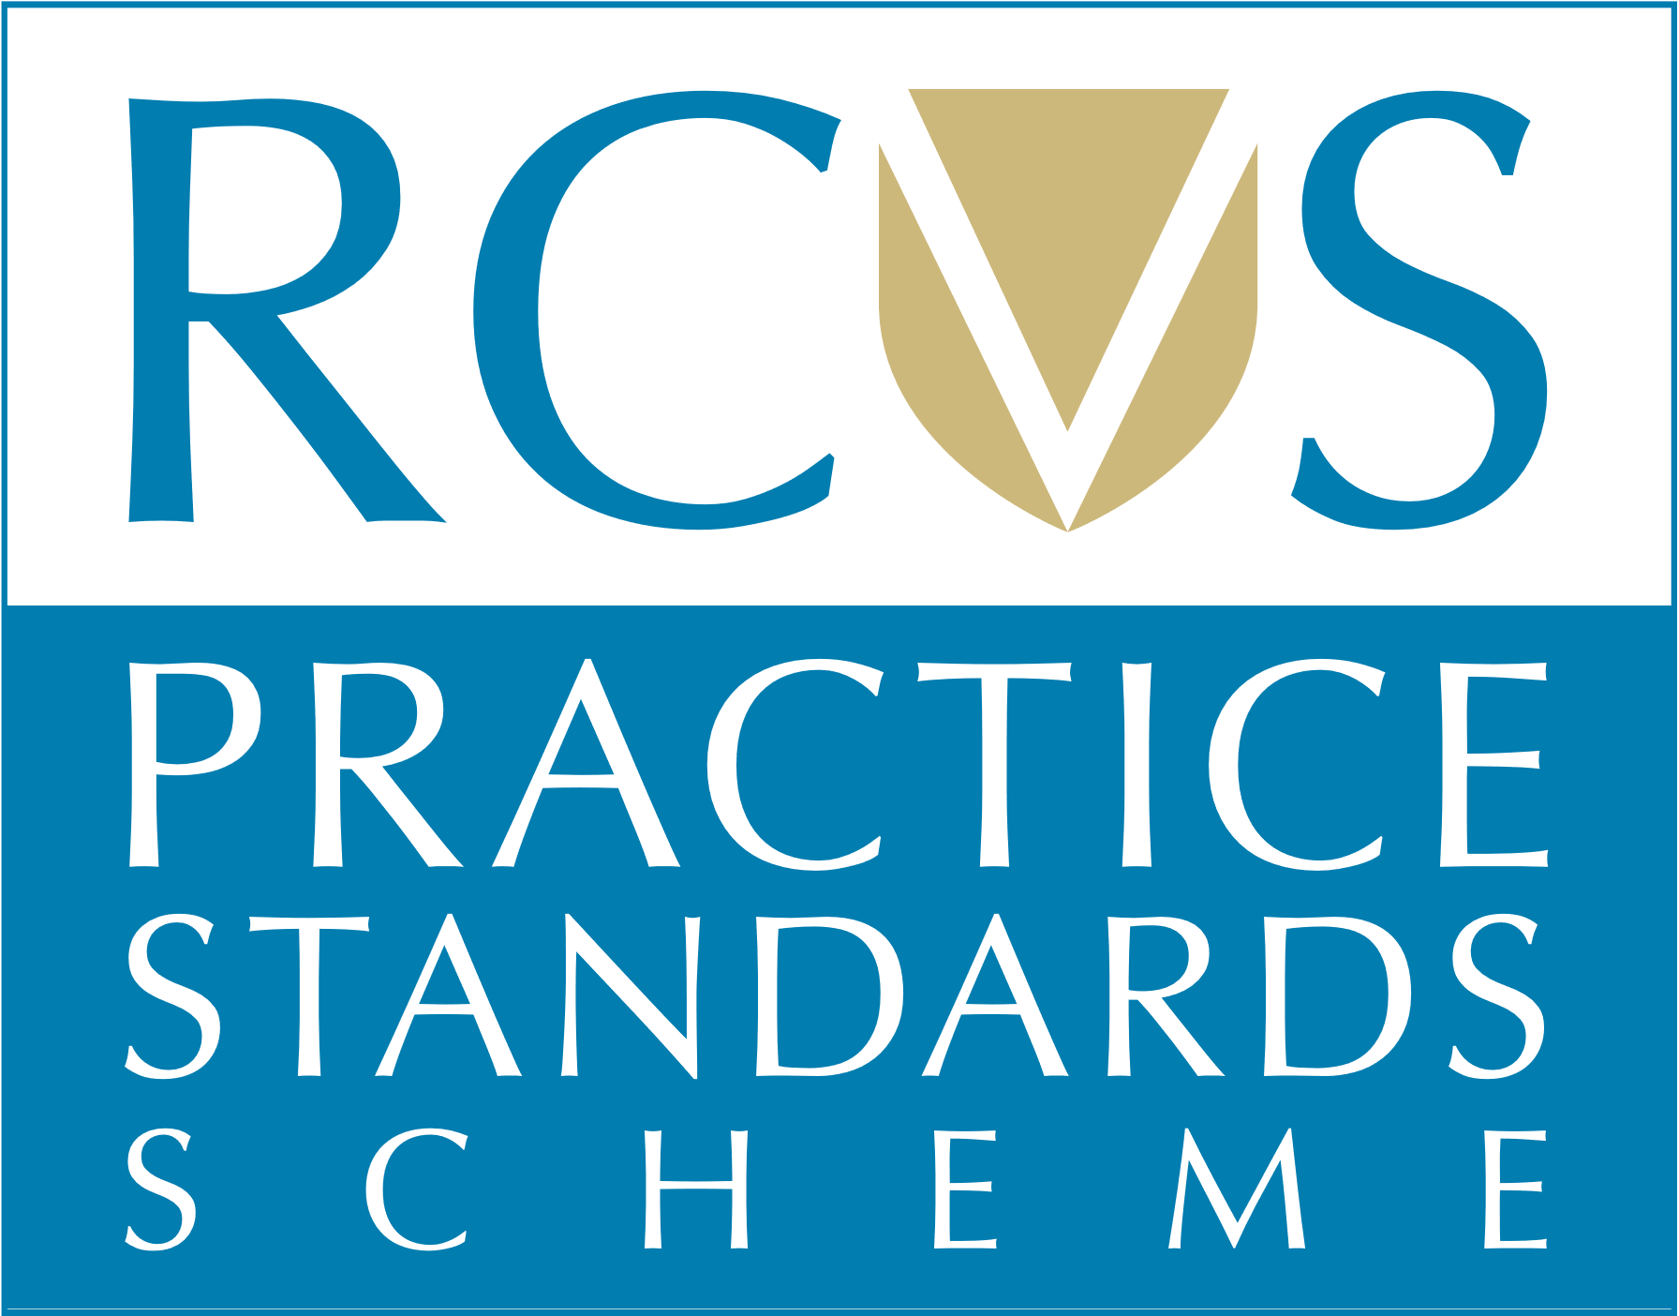
…….
NEWBURY
01635 254544
reception@coachhousevets.com
Burlyns, East Woodhay, Newbury, Berkshire, RG20 0NU

Visit us online…
www.coachhousevets.com

