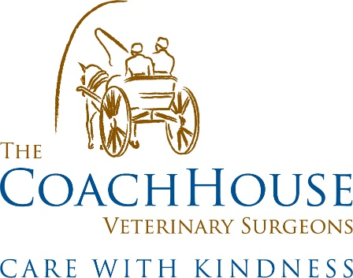
Coach House Vets Environmental Policy

Who We Are
Coach House Vets is a mixed independent veterinary practice located in the countryside on the Berkshire/Hampshire border. We have a team of 12 people made of receptionists, admins, animal care assistants, registered veterinary nurses and veterinary surgeons. Our ethos is to care with kindness and we believe that the best outcomes for you and your animals are achieved by developing a mutually trusting relationship from their first vaccination to their sad final day. We treat your animal as if it is one of our own and you as a vital member of our team.
Our Commitment
We strive to reduce our impact on the environment and demonstrate to other practices and our clients that we do all we can to reduce our footprint as are aware that the veterinary profession does impact the environment.
Our staff are committed to reducing our environmental impact as possible.

Implementation
We have a range of different ways in place to help improve our sustainability, we are always looking on how to improve constantly too.
- Recycling materials where possible (plastics, cardboard, tins)
- Ecosia search engine (plants trees on each search)
- Zone visits for equine to help reduce our petrol emissions and usage
- Review frequently to see where we can improve
- Use recycled materials where possible and safe to (our syringe brand we stock are made up of 30% recycled plastics)
- Work with suppliers who share the same ethos

Responsibility
It is the responsibility of all team staff members to ensure this policy is upheld to the highest standards and constantly improved upon.

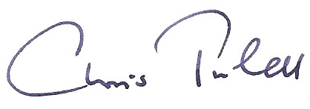
Chris Tufnell – Coach House Vets Director 13/09/23

